**EBS- 26 th August Practical – Priti Shelke**

1. **Create one instance and attached root & EBS volume**
2. Created one instance with Root volume and EBS volume

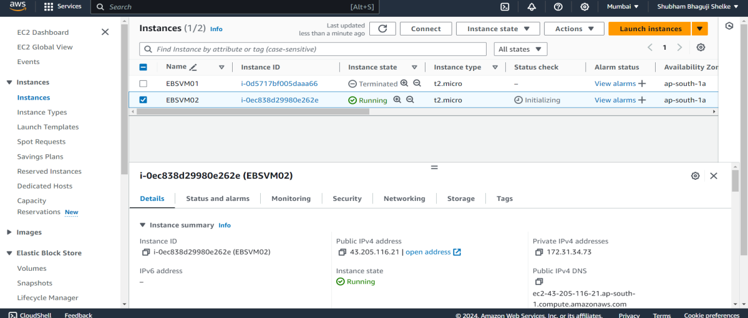

1. Attaching EBS to instance

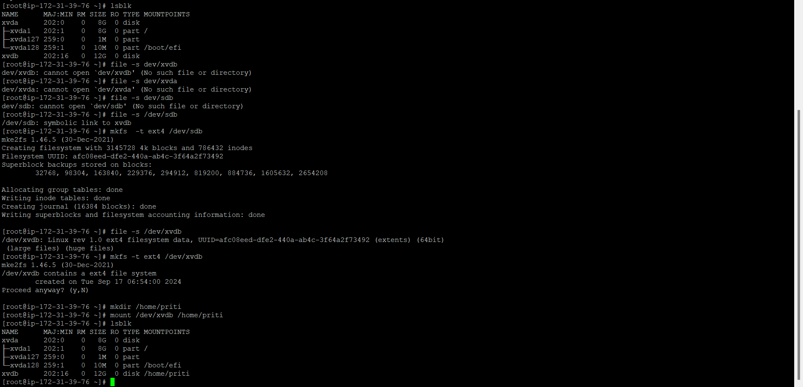

We can see both volumes are in attached state

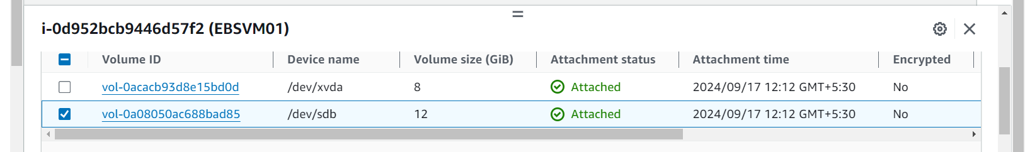

1. Increase the size of root EBS Volume.

1) To increase root EBS volume we need snapshot (Its chargeable, size of snapshot=size of volume) Created snapshot for root EBS volume

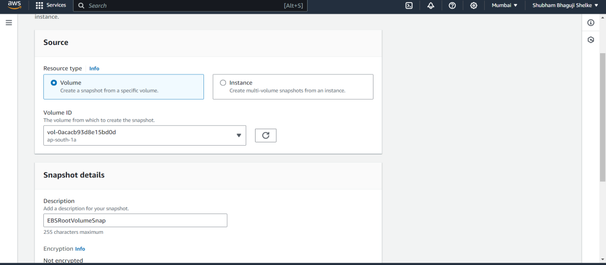

Snapshot have been created

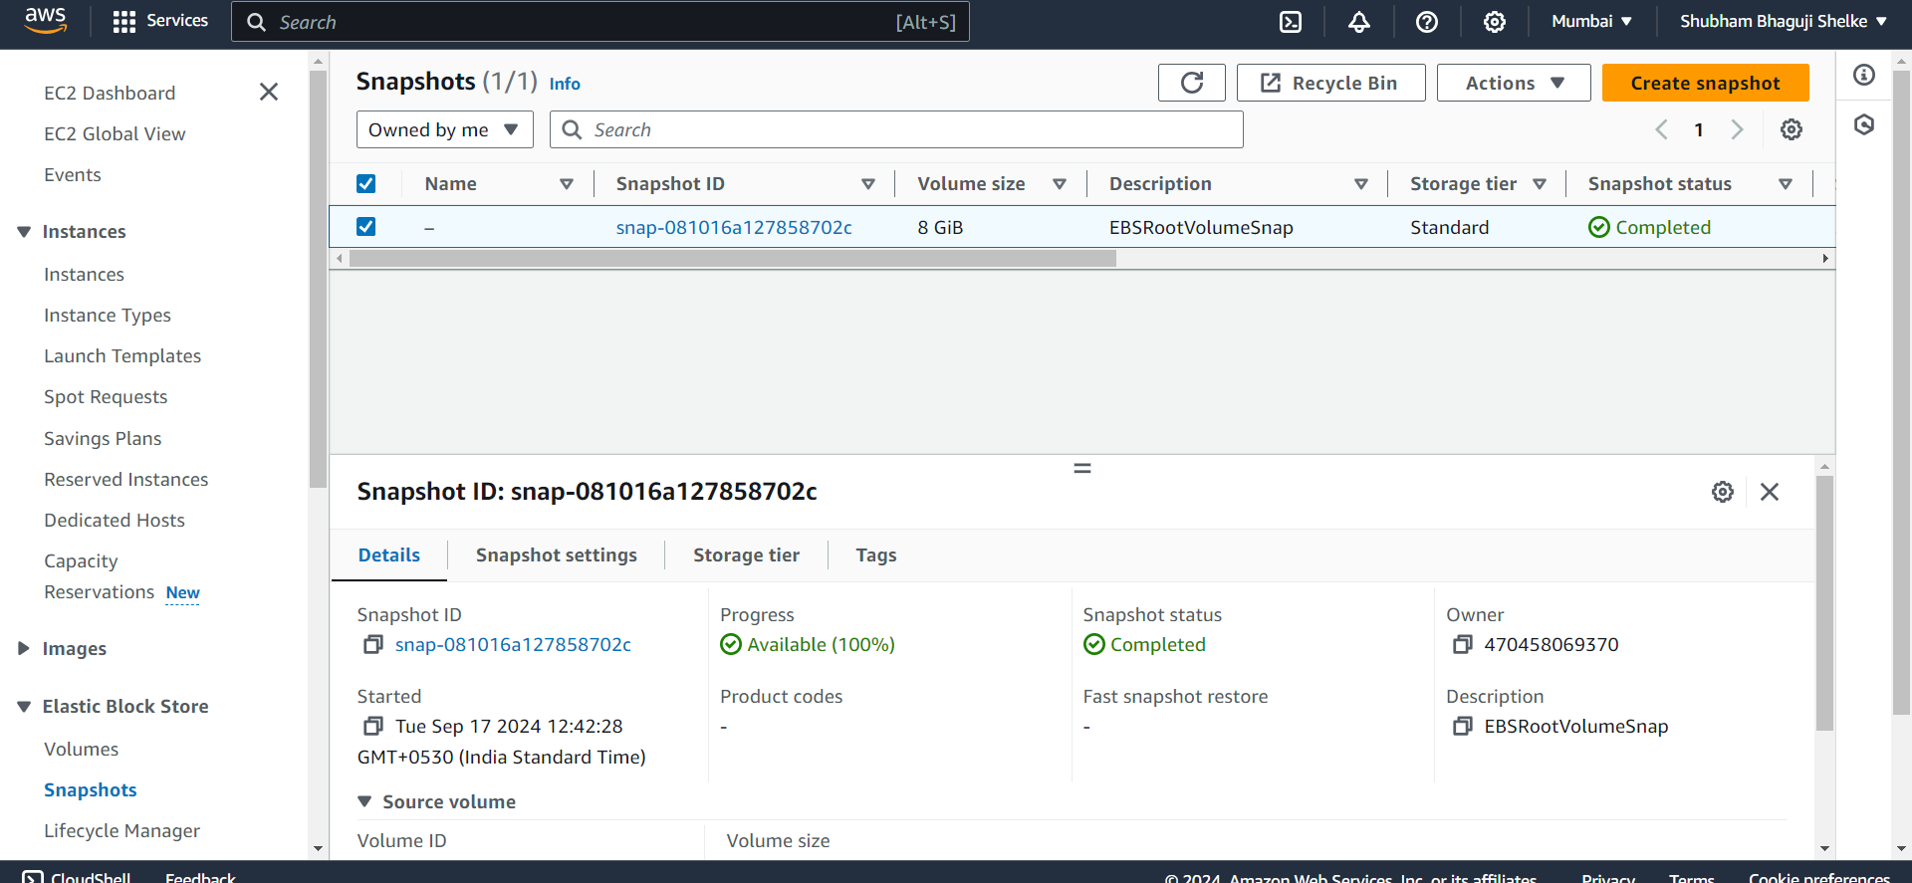

2)Create volume from Snapshot make sure availability zone should be same as instance

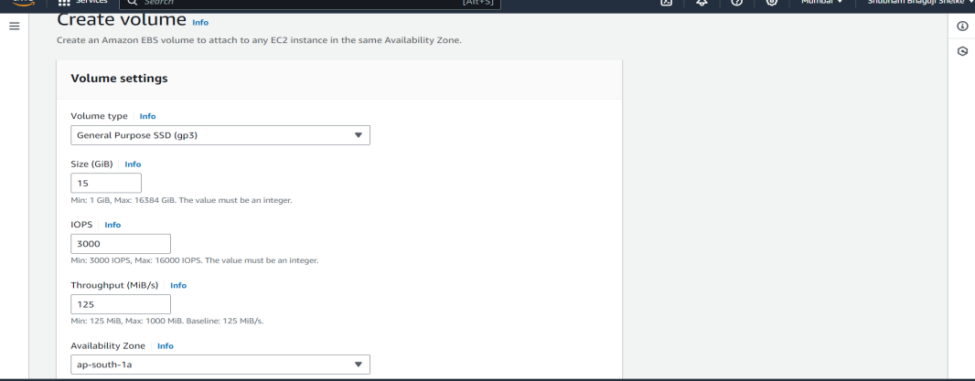

1. Stop the instance

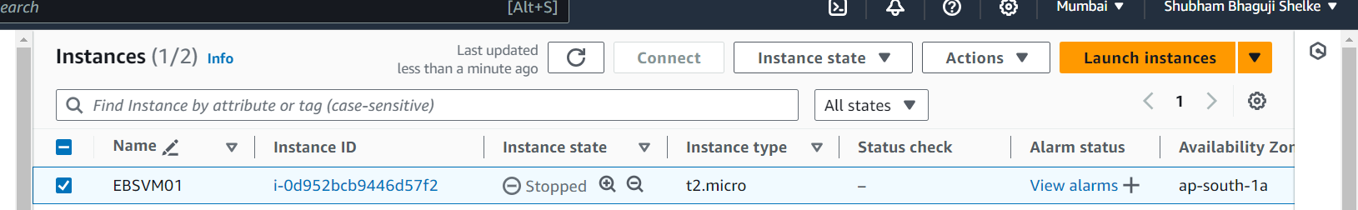

1. Detaching the EBS root volume

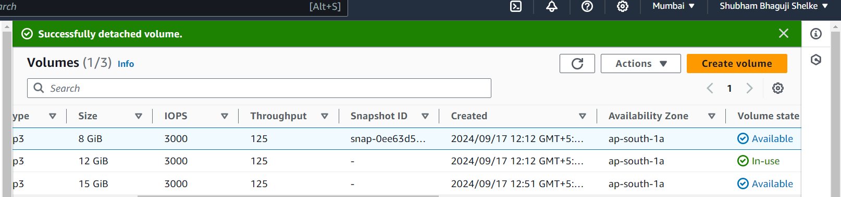

Attaching volume

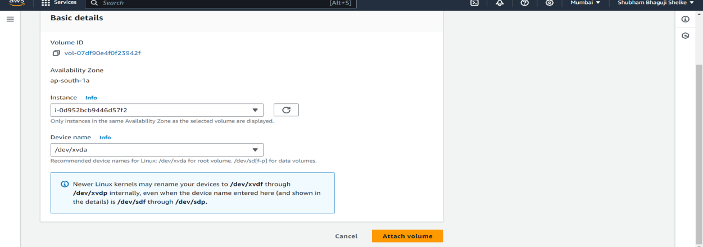

1. Now start the instance and see the volume is extended.

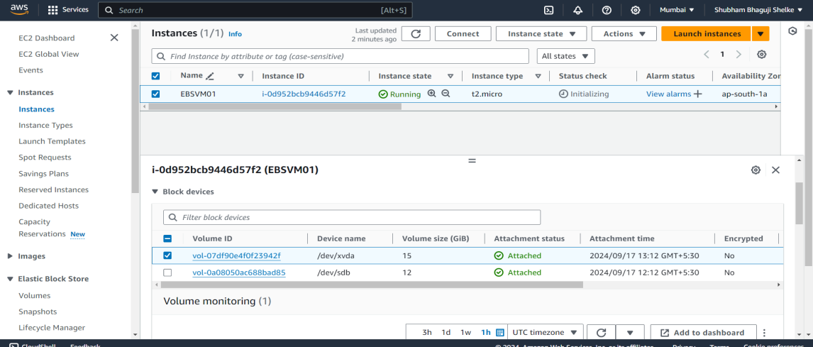

Successfully extended the root ebs volume (15GB)

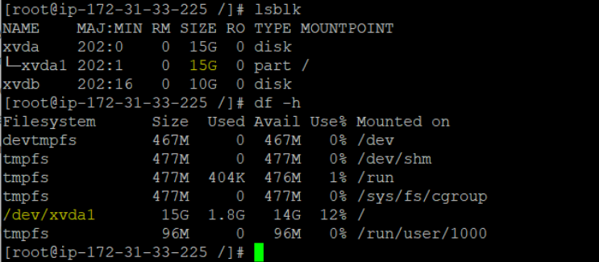

1. Increase the size of EBS Volume.
2. Creating one instance which having Root EBS and EBS volume with 8 GB space

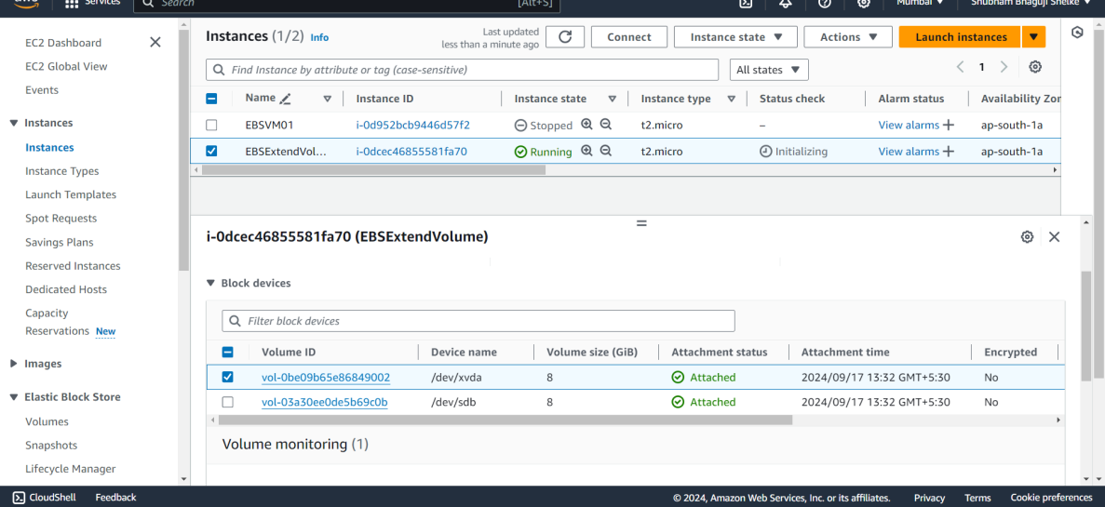

1. Need to increase the size of EBS volume

Before increase size:

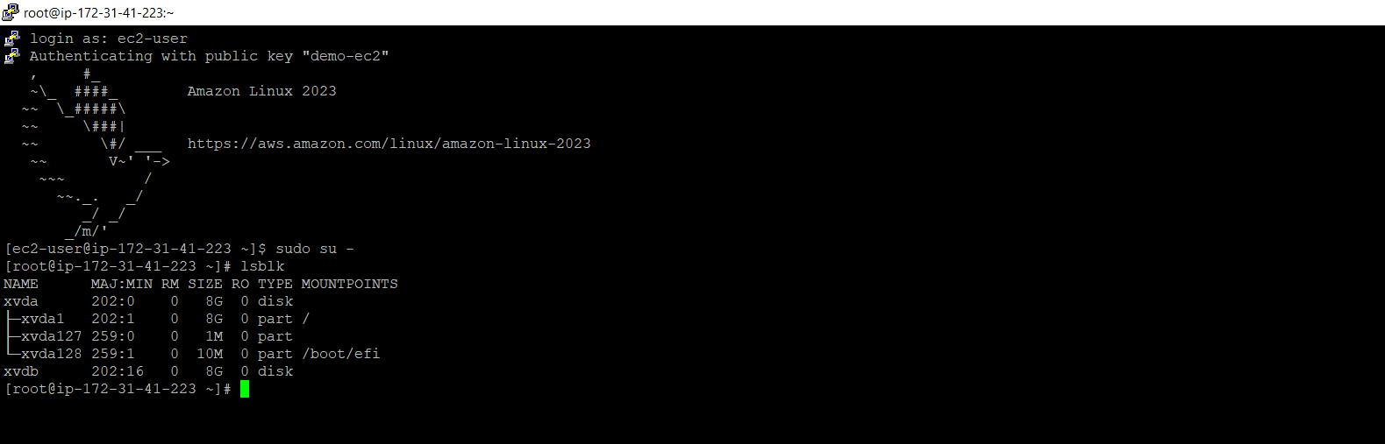

Mdifying the volume size as per requirement:

1. Successfully extended the EBS Volume

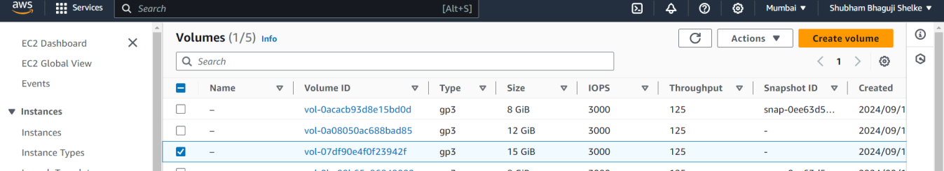

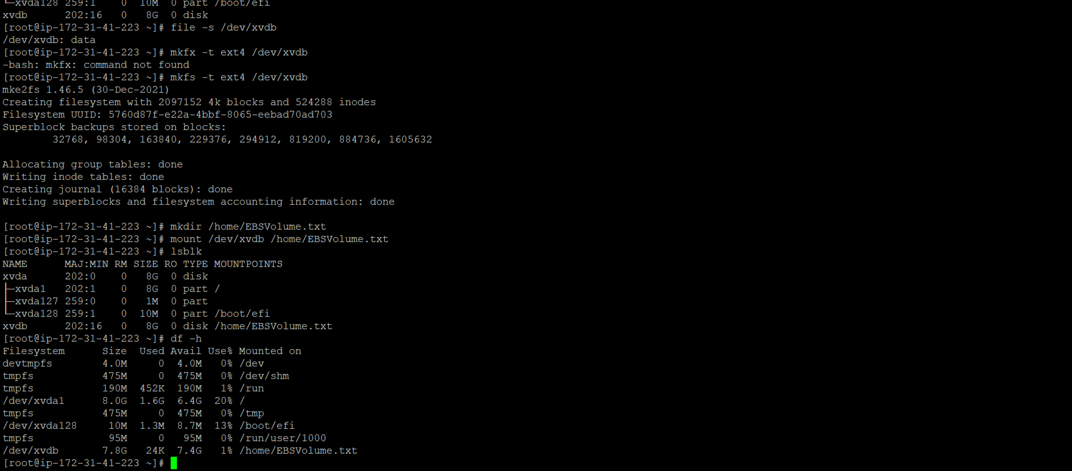

Now use resize2fs command to extend volume size

